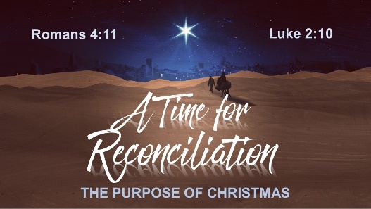
DAILY CHRISTMAS PRAYER JOURNAL: Week 3

Wednesday, December 16: Father, help me reconcile with…

_____________________________________________________

_____________________________________________________________________________

Thursday, December 17: Lord, please help my friend or family member… _______________

_____________________________________________________________________________

_____________________________________________________________________________

Friday, December 18: Dear God, this Christmas I hope …. _________________________________

__________________________________________________________________________________________

__________________________________________________________________________________________

Saturday, December 19: Lord, I am so grateful for … _______________________________

_____________________________________________________________________________

_____________________________________________________________________________

Sunday, December 20: Father, help me see … ______________________________________

_____________________________________________________________________________

_____________________________________________________________________________

Monday, December 21: God, above all else, I want you to know: _______________________

_____________________________________________________________________________

_____________________________________________________________________________

Tuesday, December 22: Happy Birthday, Jesus – my gift to you is … ___________________

_____________________________________________________________________________

_____________________________________________________________________________

