WEEK 1 … Prepare Your Heart: Look In
Take a little time to: 1. Unplug from the noise. 2. Ask a few essential questions.
Watch the sermon on Facebook HERE.

Get away from the noise and distractions of life, and create an environment to look inward, quiet your mind, and really listen to your heart. Reflect and write about these questions:

What are some things you would like to change about yourself?

______________________________________________________________________________

______________________________________________________________________________

Think about your past attempts to change. Have you made resolutions or sweeping promises to change? How well did it work?

______________________________________________________________________________

______________________________________________________________________________

Often our desire to change is fueled by regret — does regret generally propel you forward or hold you back? Be specific as to why you answered how you did.

______________________________________________________________________________

______________________________________________________________________________

In areas of your life or character that you know you need to change, are resistant to God’s grace?

______________________________________________________________________________

______________________________________________________________________________

What is the message about spiritual formation in these scriptures?

Therefore, my beloved, just as you have always obeyed me, not only in my presence, but much more now in my absence, work out your own salvation with fear and trembling; for it is God who is at work in you, enabling you both to will and to work for his good pleasure. Philippians 2:12–13

______________________________________________________________________________

______________________________________________________________________________
For I am the least of the apostles, unfit to be called an apostle, because I persecuted the church of God. But by the grace of God I am what I am, and his grace toward me has not been in vain. On the contrary, I worked harder than any of them—though it was not I, but the grace of God that is with me. 1 Corinthians 15:9–10

______________________________________________________________________________

______________________________________________________________________________
You foolish Galatians! Who has bewitched you? It was before your eyes that Jesus Christ was publicly exhibited as crucified! The only thing I want to learn from you is this: Did you receive the Spirit by doing the works of the law or by believing what you heard? Are you so foolish? Having started with the Spirit, are you now ending with the flesh? 4 Did you experience so much for nothing?—if it really was for nothing. Well then, does God[a] supply you with the Spirit and work miracles among you by your doing the works of the law, or by your believing what you heard? Galatians 3:1–5

______________________________________________________________________________

______________________________________________________________________________

Create a simple but clear statement that summarizes what “ spiritual formation” is in your own words. Include thoughts on who does what in the changing of your heart and character.

______________________________________________________________________________

______________________________________________________________________________

What distracts you from focusing on the change or the spiritual formation you desire?

______________________________________________________________________________

______________________________________________________________________________

How can we know when to relax and trust God, and when we need to exert more effort?

______________________________________________________________________________

______________________________________________________________________________

Now, quickly make a list of words that come to mind as POSSIBILITIES for your word in 2022 … don’t worry, you’ll be fine tuning these words and narrowing them down, but let your mind flow freely now and write as many words as come to mind. You’ll narrow these down in the next few weeks.

__________________________________________________________________________________________

__________________________________________________________________________________________

__________________________________________________________________________________________

The WHY is ALWAYS more important than the WHAT!!!

My One Word. Ashcraft, Mike; Olsen, Rachel. Zondervan.
One Word That Will Change Your Life. Dan Britton, Jimmy Page, and Jon Gordon. Wiley.

WEEK 2 … Discover Your Word: Look Up
Spend some time with God to: 1. Unplug from the noise. 2. Ask yourself a few essential questions.
WATCH THE SERMON on FACEBOOK HERE.

You probably don’t have any idea what your word is going to be this New Year and please don’t rush! Instead of randomly picking a word, allow God to let His word choose you. Your word will come! If you are open, the word always comes, a word that is meant for you to help you become all God wants you to be! If you believe it, if you ask Him for it, you will receive it. With that said, there are some questions you can ask yourself to have a receptive heart.

What areas of your life do you struggle with? Anxiety? Finances? Loneliness? Control? Addiction? Boredom? Jot down those words now:

___________________________________________________________________________________

How does these texts speak to you?
God’s righteousness comes through the faithfulness of Jesus Christ for all who have faith in him. There’s no distinction. All have sinned and fall short of God’s glory, but all are treated as righteous freely by his grace because of a ransom that was paid by Christ Jesus. Romans 3:23

___________________________________________________________________________________

Therefore, once you have your minds ready for action and you are thinking clearly, place your hope completely on the grace that will be brought to you when Jesus Christ is revealed. Don’t be conformed to your former desires, those that shaped you when you were ignorant. But, as obedient children, you must be holy in every aspect of your lives, just as the one who called you is holy. It is written, You will be holy, because I am holy. 1 Peter 1:16

___________________________________________________________________________________

What Bible verse speaks to your heart? Once you identify what your struggles are, consider Bible verses that address that particular thing. Some Bible indexes will help, but Google any word + SCRIPTURE and you’ll find lists of text. Once you read through scripture that address your primary identified struggle, choose 1 or 2 scriptures that speak to you.

___________________________________________________________________________________

___________________________________________________________________________________

___________________________________________________________________________________

What areas in your life have you NOT surrendered? Our goal is for God would mold us more and more into His image & this means we must be willing to allow Him into every part of our hearts. “But now, O LORD, You are our Father, We are the clay, and You our potter; And all of us are the work of Your hand.” (Isaiah 64:8) Consider those things you have not been able/willing to turn over to God.
___________________________________________________________________________________
What are you passionate about? The things you love the most may be the key to your word of the year. Jot down things that are important to you, ways you like to spend your time, etc. 1 Corinthians 10:31 says: So, whether you eat or drink, or whatever you do, do all to the glory of God.

___________________________________________________________________________________

Which Fruit of the Spirit most resonates with your heart? We should display these characteristics at all times but is there a SPECIFIC word that God is leading YOU toward? If so, explore that word more deeply. Love, Joy, Peace, Patience, Kindness, Goodness, Faithfulness, Gentleness, Self-control. Galatians 5:22-23

___________________________________________________________________________________

What is God telling you in prayer? With intentional, quiet, one-on-one time with God, He will give us the wisdom you seek. Jot down the words that come to your mind after reading these texts.
But anyone who needs wisdom should ask God, whose very nature is to give to everyone without a second thought, without keeping score. Wisdom will certainly be given to those who ask. James 1:5

___________________________________________________________________________________

I pray that the God of our Lord Jesus Christ, the Father of glory, will give you a spirit of wisdom and revelation that makes God known to you. Ephesians 1:17

___________________________________________________________________________________

I will bless the Lord who advises me; even at night I am instructed in the depths of my mind. I always put the Lord in front of me; I will not stumble because he is on my right side. Psalm 16:7-8

___________________________________________________________________________________

Now, make a list of any words that have been swirling in your head.

____________________________________________________________________________

____________________________________________________________________________Have you ever played word games on a road trip? There are so many of them but The Categories word game starts with a person selecting a particular category of items and each player must take turns naming items in that category until no one can think of any more items to add. Like … things to bring to the beach? (towel, sunscreen, shovel, etc.) or items found in a kitchen? (plates, oven, mixer, etc.) or names of candy bars? (Snickers, Milky Way, Butterfinger, etc.). Pick of to 5 of the words you just listed and add other words that would fit in its category. i.e. if your word is THANKFUL, let all the words associated with thankful to flow onto the paper. (Grateful, happy, glad, humble, appreciate, etc.) ASK GOD TO GUIDE YOU! If one word leads to another write that down as well.

____________________________________________________________________________

____________________________________________________________________________

____________________________________________________________________________

____________________________________________________________________________

____________________________________________________________________________

NEXT WEEK we’ll begin narrowing down words … again, be patient … let God do His part!

“Your word of the year is shorthand for the person you want to become … it’s something that will help remind you why it is important to make good choices in life and how doing so can make your life more rewarding each day and your relationships, with God and others,
even STRONGER. Victoria Riollano”

My One Word. Ashcraft, Mike; Olsen, Rachel. Zondervan.
One Word That Will Change Your Life. Dan Britton, Jimmy Page, and Jon Gordon. Wiley.

WEEK 3 … Choose Your Word: Looking To God
Take a little time to: 1. Unplug from the noise. 2. Ask a few essential questions.
WATCH THE SERMON on FACEBOOK HERE.
You still may not have a clear understanding of what Your word is going to be this New Year. That's okay. It doesn’t always come right away so give it some time this week. Instead of randomly picking a word, allow God to help the word choose you. Don’t worry - your word will come as you begin to narrow down your list.
In the Bible, imagery of refining silver is powerful: in order to yield pure silver or gold, ore has to be smelted in a fiery furnace over and over, up to seven times. Each time the ore is heated, any impurities in the metal start to disappear. This process leaves behind pure, precious metals without defect. The process is effective, but not easy. Going through the spiritual formation process of finding God’s ONE WORD requires some commitment, but when we’re refined we grow more into the image of Jesus and our lives will change for the better! Jesus is our “refiner and purifier” (Malachi 3:3) List the 2 things in your life that you’ve discovered need some refining:
______________________________________________________________________________________
______________________________________________________________________________________After Christ rose from the dead, He appeared to more than 500 people, including all the apostles, before ascending into heaven. Later, Jesus returned to earth to confront one of His biggest persecutors, Saul, and when they met on the Road to Damascus, Saul was overcome by the good news of salvation! Not only did Saul turn his life over the Christ, but he was transformed after being name Paul, and he became one the most committed disciple makers of all time! Paul wrote: For I am the least of the apostles and do not even deserve to be called an apostle, because I persecuted the church of God. But by the grace of God, I am what I am, and his grace to me was not without effect. No, I worked harder than all of them—yet not I, but the grace of God that was with me. 1 Cor. 15:9-10 Where/how has God offered YOU grace in this last year?

_________________________________________________________________________________________

_________________________________________________________________________________________
What does it feel like to be loved unconditionally by God? How does this love transform you and make you

new?_____________________________________________________________________________________

_________________________________________________________________________________________
Reflect on this quote: “I am not what I might be, I am not what I ought to be, I am not what I wish to be, I am not what I hope to be. But I thank God I am not what I once was, and I can say with the great apostle, “By the grace of God I am what I am.”—John Newton (1 Corinthians 15:10). Who do you wish to be in 2022? What is God calling you to BECOME in this new year?
__________________________________________________________________________________________
__________________________________________________________________________________________
Contemplate this text: The righteousness that I have comes from knowing Christ, the power of his resurrection, and the participation in his sufferings. It includes being conformed to his death 11so that I may perhaps reach the goal of the resurrection of the dead. It’s not that I have already reached this goal or have already been perfected, but I pursue it, so that I may grab hold of it because Christ grabbed hold of me for just this purpose. Brothers and sisters, I myself don’t think I’ve reached it, but I do this one thing: I forget about the things behind me and reach out for the things ahead of me. The goal I pursue is the prize of God’s upward call in Christ Jesus. So all of us who are spiritually mature should think this way, and if anyone thinks differently, God will reveal it to him or her. Phil. 3:10-17 How does this scripture speak to you:
_______________________________________________________________________________________

_______________________________________________________________________________________ List 3 words God has been strongly revealing to you, words you have prayed about & considered related scriptures for:
WORD HOW WILL THIS WORD HELP ME GROW IN MY RELATIONSHIP WITH JESUS CHRIST?
1__________ ___________________________________________________________________________

___________________________________________________________________________

2__________ ___________________________________________________________________________

___________________________________________________________________________

3__________ ___________________________________________________________________________

___________________________________________________________________________
WORD HOW WILL THIS WORD HELP ME BECOME A BETTER PERSON in 2022?
1__________ ___________________________________________________________________________

___________________________________________________________________________

2__________ ___________________________________________________________________________

___________________________________________________________________________

3__________ ___________________________________________________________________________

___________________________________________________________________________
Dear Heavenly Father, I am asking You to reveal just One Word to me this week. I pray that Your word will help me become a better person for You and I am ready to receive a word meant for me in 2022. In Jesus’ name, I ask. AMEN.
With God’s guidance I believe my ONE WORD for 2022 is: (I’m not sure, so I will continue to pray this week about this word also)____________________________________________________ __________________________________________________________________________________
My One Word. Ashcraft, Mike; Olsen, Rachel. Zondervan.
One Word That Will Change Your Life. Dan Britton, Jimmy Page, and Jon Gordon. Wiley.
Live Your Word: Look Around
Spend some time with God to:
1. Unplug from the noise. 2. Ask yourself a few essential questions.
WATCH THE SERMON on FACEBOOK HERE.

"Lord, I pray for a breakthrough year. Use this One Word theme to bring You glory. Stretch me through this process. Reveal to me truth and revelation. Please make it plain to me. Speak, Lord,
Your servant is listening. In Jesus’ name, Amen.”

Once you discover the word that is meant for you, it’s time to live it out!

When your One Word comes to you, it may come in the form of a character trait, a discipline, a spiritual focus, an attribute or a value. Because it is only ONE WORD, living out God’s word for you will keep you focused and prevent you from being distracted from HIS purpose. Your word will also have impact in all areas of your life: physical, intellectual, spiritual, and relational and over time, you will live your word naturally.

The process is exhilarating, but it will also prove to be challenging: you’ll face obstacles you didn’t anticipate, and you will be stretched, but when you step out of your comfort zone to be obedient to God, great things happen so stay the course and prepare to be AMAZED by God!

REFLECT ON THIS SCRIPTURE FROM NEHEMIAH: when Nehemiah asked for permission to return to Jerusalem and rebuild the Temple that had been destroyed by the Babylonians, nothing could stop him! Just as the gates were being completed, enemies of God’s people tried to trick Nehemiah into coming out of the city to meet them in an outer village and Nehemiah said this:

I knew they were scheming to hurt me so I sent messengers back with this: “I’m doing a great work; I can’t come down. Why should the work come to a standstill just so I can come down to see you?” Four times they sent this message and four times I gave them my answer. The fifth time—same messenger, same message—Sanballat sent an unsealed letter with this message: “The word is out among the nations—and Geshem says it’s true—that you and the Jews are planning to rebel. That’s why you are rebuilding the wall. The word is that you want to be king and that you have appointed prophets to announce in Jerusalem, ‘There’s a king in Judah!’ The king is going to be told all this—don’t you think we should sit down and have a talk?” I sent him back this: “There’s nothing to what you’re saying. You’ve made it all up.” They were trying to intimidate us into quitting. They thought, “They’ll give up; they’ll never finish it.” I prayed, “Give me strength.” Neh. 6:2-9

How does this text make you committed to YOUR purpose?

___________________________________________________________________________________
What will be a short, breath prayer YOU can prayer when you experience roadblocks to being faithful to God’s purpose for you this year?

___________________________________________________________________________________

God’s ONE WORD should be a roadmap to reflect the image of Christ in all areas of your life. In order to become the person God wants you to be, answer these questions the boxes below: How will my word guide me in this area of my life? What challenge do I see in each area of my life and how can I combat that challenge using God’s ONE WORD?
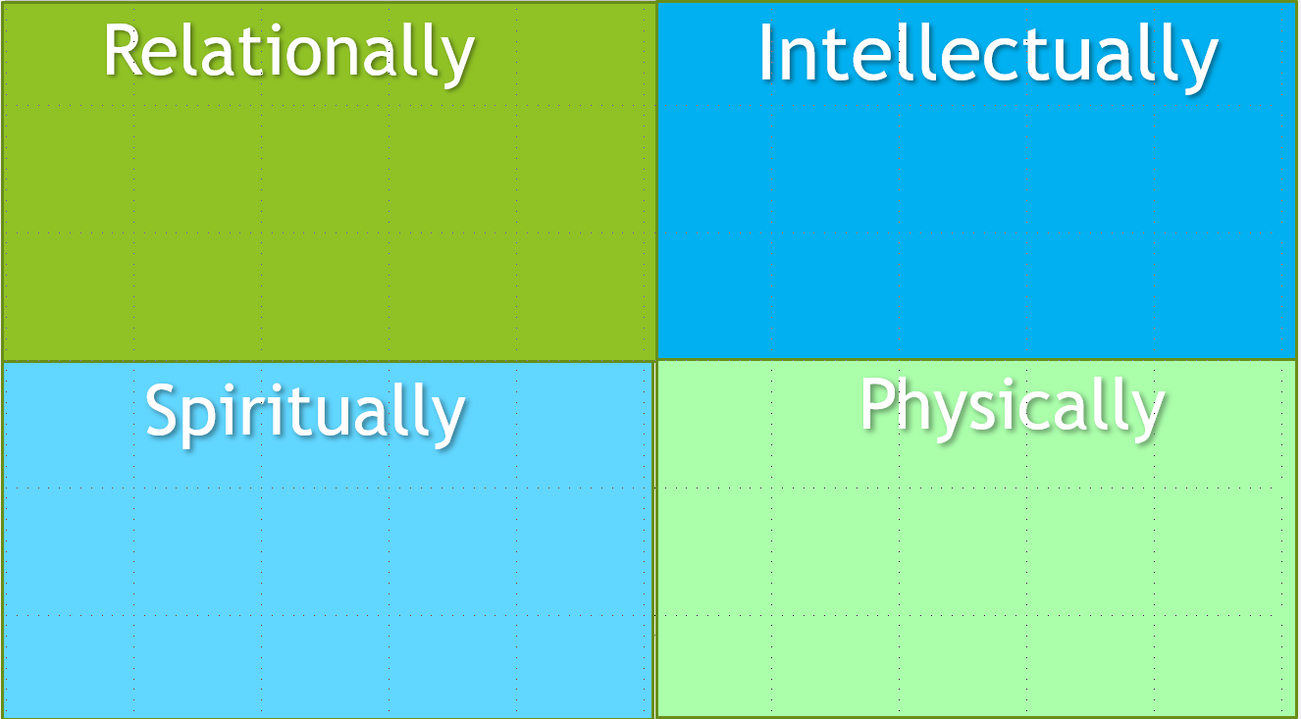

It’s essential to keep your one word front and center, list your accountability partners, family members, friends, Sunday school group partners, etc. who you can/will talk to about God’s word for you.

List 4 ways/places that you plan to keep God’s word VISIBLE in your life?

1._________________________________________________________________________________

2. _________________________________________________________________________________

3. _________________________________________________________________________________

4._________________________________________________________________________________

Pray that this year is a breakthrough year for you as the Lord takes you to the next level in your faith journey and uses your One Word to bring Him glory!

My One Word. Ashcraft, Mike; Olsen, Rachel. Zondervan.
One Word That Will Change Your Life. Dan Britton, Jimmy Page, and Jon Gordon. Wiley.

